The former minister of education will lecture in Kroměříž
Petr Piťha on the importance of
the Cyrillo-Methodian mission
Kroměříž 19th October 2012
In 2013, Czech society will commemorate the 1150th anniversary of the arrival of the Solun brothers to Great Moravia. Prof. Petr Piťha, who is a priest, a pedagogue and the former minister of education, will familiarize citizens of the Kroměříž district with the significance of the anniversary and the legacy of Saints Cyril and Methodius for Czech statehood and the present within his lecture which will take place in the Museum of Kroměříž District on 7th November at 4:30 p.m. At the same time, there will be an exhibition opening taking place in the premises of the museum, which will introduce poetic illustrations by Klára Folvarska-Roseova, the academic painter who illustrated Piťha’s book Slyšte slovo a zpívejte píseň (Hear the word and sing the song) which in a comprehensible way familiarizes young people with the lives of Saints Cyril and Methodius and with the story of Velehrad. Visitors to the museum will be able to view this exhibition by 25th November of this year. The event is organized by the museum and the Czech Christian Academy in cooperation with the UNESCO Club
and the Matice Velehradska Foundation.

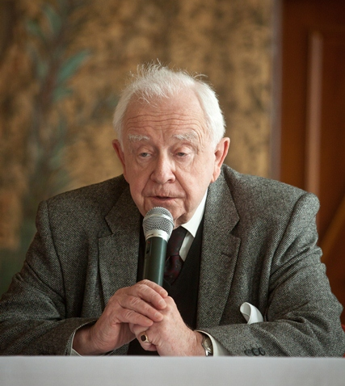
Prof. PhDr. Petr Piťha CSc. (Photo by F. Ingr)

More detailed information:
Prof. PhDr. Petr Piťha was born in Prague in 1938. He studied the Czech language, general linguistics and history at the Faculty of Arts at Charles University in Prague. He worked as a linguist at the Charles University Faculty of Mathematics and Physics till 1990. After that, he was asked to establish a department of Education to Citizenship at the Faculty of Education at Charles University. There he prepared the first after-the-revolution programs for the first and second levels of primary schools called General and Civil school. From 1992 to 1994 he was the minister of education. After that, he worked at his department until he retired in 1998.
In 1959, he secretly began to get ready for his priestly ordination and he was ordained a Catholic priest in the Netherlands in 1969.
He was awarded J. A. Komensky medal - Unesco and New Europe Price. In 2011, he was awarded the highest state decoration by the President of the Czech Republic Václav Klaus called Medaile Za zásluhy (the Medal of Merit).
Within the preparations for the 1150th anniversary of the arrival of Saints Cyril and Methodius to Great Moravia, Prof. Piťha strives, by means of an extensive publication activity and lectures, to increase the awareness of Czech society regarding the significance of the legacy of Saints Cyril and Methodius for the present. In this connection he published, in cooperation with the Matice Velehradska Foundation, a book titled Slyšte slovo a zpívejte píseň (Hear the word and sing the song). In its first part, the book describes, in a readable way, the life stories of Saints Cyril and Methodius. The author of the book, Prof. Petr Piťha, lists all the fundamental historical facts without disrupting the continuous flow of narration. Readers are, at the same time, getting amused and educated.
In the second part, by means of several historical images the author leads the reader through the most important periods of the history of Velehrad and the development of Cyrillo-Methodian reverence. That at the same time shows what our present task regarding protection and augmentation of the “legacy of our fathers” is.
Citizens of Kroměříž can view more than 70 illustrations created for the publication by academic painter Klára Folvarská-Roseová within the exhibition in the Museum of Kroměříž District. The impressiveness of the illustrations is raised to a power by means of adjustment including quotations from the book.

